M.C. Escher and Optical Art {making 2D into 3D}

|  |
| --- |
| **Big Idea:** Artists use art to alter their visual reality |
| **Grade:** Eighth, 3D art  **Duration:** 7-8 50 minute periods |

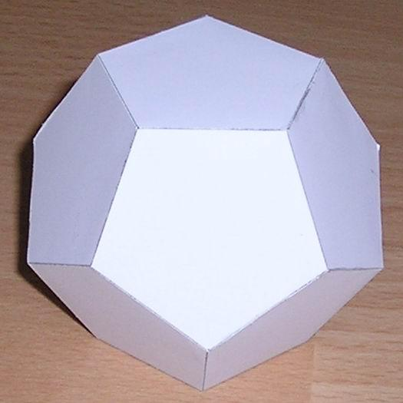

**Lesson Summary:** We will discuss Optical art and the artist MC Escher. Students will create a dodecahedron out of paper. Each side will be decorated with a pattern that is, or is inspired by optical illusions.

|  |  |
| --- | --- |
| **Key Concepts** | **Essential Questions** |
| * There are many ways to alter reality * Fantasy and surrealism needs an element of reality to be convincing * Our perception is our reality | * Why base fantasy and surrealism in reality? * How do artists alter our perceptions? * Why/how do optical illusions work? * Why do artists alter reality in their artwork? |

**Standards:**

* 9.1.8.A. Know and use the elements and principles of each art form to create works in the arts and humanities.
  + Elements: • color • form/shape • line • space • texture • value
  + Principles: • balance • contrast • emphasis/focal point • movement/rhythm • proportion/scale • repetition • unity/harmony
* 9.3.8.C. Identify and classify styles, forms, types and genre within art forms (e.g., surrealism vs. optical art).
* 9.4.8.D. Describe to what purpose philosophical ideas generated by artists can be conveyed through works in the arts and humanities (e.g., T. Ganson’s *Destructive Periods in Russia During Stalin’s and Deniken’s Leadership* conveys her memories and emotions of a specific incident).

|  |  |
| --- | --- |
| Artist: M.C. Escher | Art: Optical Art |
|  | |

|  |  |
| --- | --- |
| **Objectives** | **Assessment** |
| Knowledge   * Students will define Optical Art and explain how it works * Students will research types of illusion and optical art   Skills   * Students will create an optical pattern or illusion (using repetition) for the sides of their dodecahedron * Students will construct a dodecahedron out of paper, using measurement skills   Dispositions   * Students will discuss in class, and through worksheets, the purpose of optical art * Students will inquire about how and why artists alter our perceptions of reality. | Pre-Assessment   * Illusion hook   Formative   * Student created/filled in Op Art powerpoint * Optical illusion worksheet/brainstorming sheet   Summative   * Completed dodecahedron, constructed with optical patterns * Student reflection sheet about Escher, optical art, and perception/reality * Optical Dodecahedron rubric |

|  |
| --- |
| **Interdisciplinary Connections:** |
| * Math: Using measuring and geometry to create illusions and construct a dodecahedron * Science: Learning about optics and how the eye works |
| **Instructional Procedures:** |
| **Day 1**  **Motivation:** To begin this lesson, I will hook the class by showing and asking them to participate in some optical illusions on the projector. I will ask students to describe what is happening in each illusion, or ask them to guess how different illusions work.  **Development:** I will then discuss MC Escher and his work with surrealism and optical art. We will look at some of his optical illusions and tessellations, and discuss the basis that MC Escher’s work has in math. We will also discuss his realism vs. surrealism, and why they are linked. Then, we will return to the idea of optical illusions. Because each student has Students will collaboratively fill out a powerpoint (in google slides) about optical art, defining it, discussing the science behind it, and giving example of different kinds of illusions. Each table will be assigned a slide of the base powerpoint to fill in as a table group. Each table group will then share their findings with the class.  **Closure:** To end the day, I will use the last few minutes of class to have students begin to fill out a mini brainstorm sheet for Optical Art. This will get students to begin thinking about optical patterns and how they work and can be applied. Students may use books or the internet to research optical patterns and designs for inspiration.  **Day 2**  **Motivation:** To begin the day, I will introduce the lesson, and tell students what we will be making, as well as show examples. This will get students excited to design their own optical dodecahedrons. I will give them a little more time to finish up their brainstorm sheet from the previous day before moving on.  **Development:** I will demonstrate how to create an optical pattern for the sides of their dodecahedrons, and we will discuss the various options they have for creating their own illusion. Students will have the class period to work on their designs. I will provide templates for students to work with, and demonstrate using the transfer method to create a symmetrical pattern. If students are ready, I will also demonstrate how to create the “flowers” that we will make to create our dodecahedrons.  **Closure:** I will ask students to simply hold up their designs towards the opposite side of the room so that each side can see what their peers were working on. I will ask students if they saw any of their peers work that surprised or inspired them, or something similar to what they were thinking. I will also mention that students will start out class the following day working on their designs if they are not finalized.  **Days 3-5:** Work Days  Students will have these days to work. First they will design their optical pattern on a brainstorming sheet. Then they will begin tracing out their flowers and pentagons and drawing their patterns on. They should finish all 12 by the end of day 5.  **Day 6:** Construction day!  **Motivation:** I will begin the day by gathering the class at a table to view a demonstration of how to properly construct their dodecahedrons. I will discuss scoring the fold lines, as well as their construction options (tabs in of tabs out). I will demonstrate the gluing process using elmer’s glue, and be sure to tell students that they must hold each seam for at least 30 seconds while the glue sets. If students are building their forms with the tabs in, I will explain the best way to attach the last piece (cutting the tabs off and setting it atop the tabs of neighboring “flowers”).  **Development:** After the demo, students will cut out, score and fold their patterned “flowers.” They will begin gluing them together in a flower format. They will have the full day to glue their dodecahedrons.  **Closure:** To end the day, I will ask any students who finished gluing to hold their dodecahedrons up in the air for the class to see. Hopefully seeing some of their peers finished products will keep students motivated through the frustrating gluing process.  **Day 7**  **Motivation:** To begin the day, I will motivate students by playing the *Final Countdown*, because this is our last “finishing up” day.  **Development**: Students will have about 35 minutes to work on and finish up their dodecahedrons. At that point, no matter where they are in the process, we will stop and place all of the dodecahedrons, finished or not, on a table so that we can see them all done, or at least in progress. Students will have a few minutes to view their peers work and to discuss it.  **Closure:** Students will have the last few minutes of class to fill out an Optical Art reflection sheet. It will ask students to think about optical art and how they used it, as well as reflect on strengths and weaknesses with the project. This will be their exit ticket to leave class.  **\*\*\*\*\*\*\*Enrichment:** Throughout the whole process, students will be working on a sketch book assignment dealing with optical art. |

**Adaptations:**

* Learning Disabilities: For this project, instead of having students trace out their own “flowers” I will provide students with the template so that they can focus on their design. If needed, I can also create a template for their designs. If they are running out of time, it would also be possible to copy their design, so that they don’t need to make all 12 “flowers” by hand. They may also choose one color to add to their patterned “flowers.”

|  |  |
| --- | --- |
| Resources/Preparation | Materials |
| * <http://www.optics4kids.org/home/content/illusions/> * <https://www.insidescience.org/content/how-do-optical-illusions-work/3066> * <http://www.mcescher.com/about/biography/> * <https://en.wikipedia.org/wiki/List_of_optical_illusions> * <http://www.wikihow.com/Draw-an-Impossible-Triangle> * <http://mathworld.wolfram.com/OuchiIllusion.html> * <https://www.youtube.com/watch?v=4v8605UpmbI> * Optics and illusion info and think sheet * Dodecahedron construction step by step sheet * Student reflection sheet | * Pencil * Sharpies * Dodecahedron template * White paper (enough for 12 “flowers template pieces”) * Colored markers (one color besides black and white) |

|  |
| --- |
| Student Work: |
|  |