From Earth to Home: Native American Pinch Pots

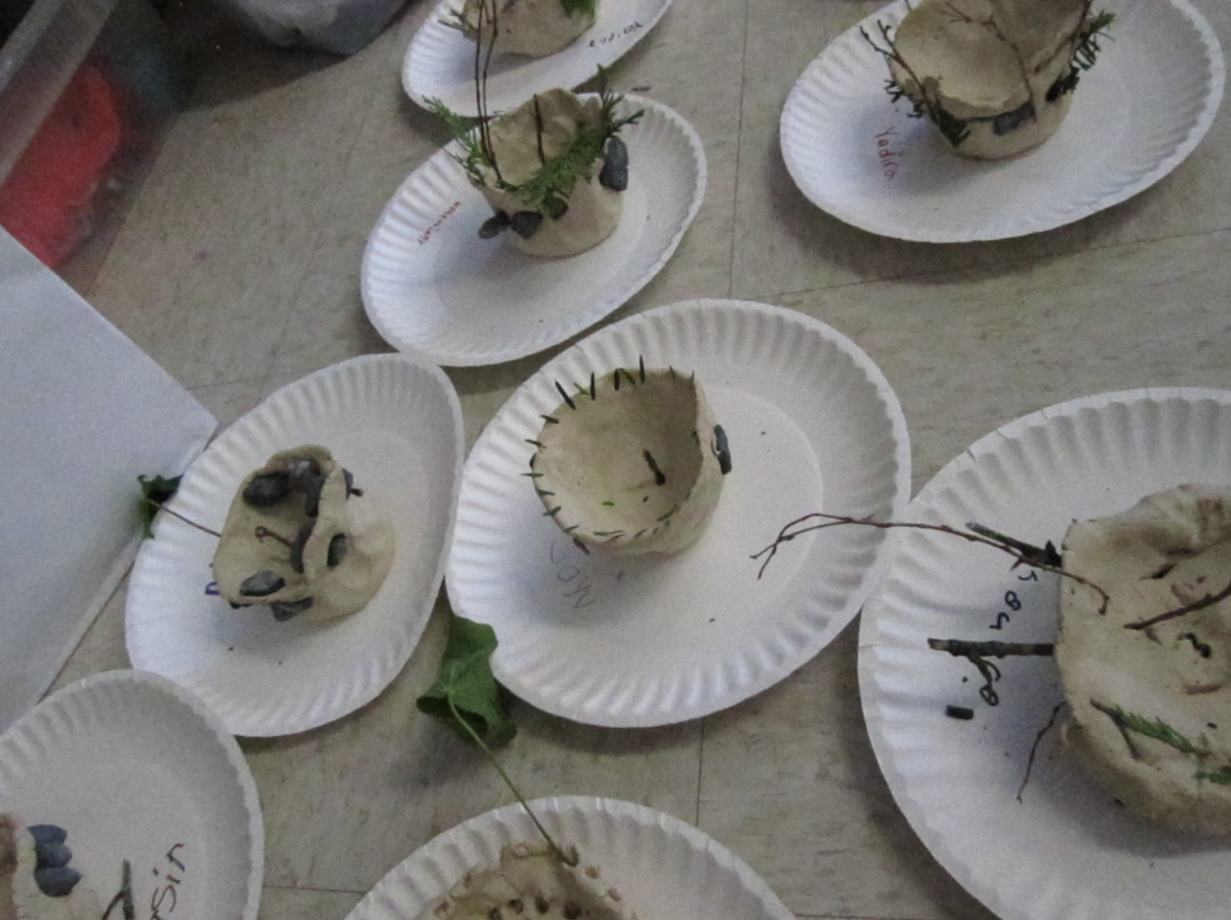

Melissa Way
ARU 110, Spring 2012
Dr. Wunder
Big Idea: Throughout time and across cultures, humans have used natural materials to make useful items.

Lesson Title: From Earth to Home: Native American Pinch Pots
Grade: 1
Time Allotment: Three 45 min. class periods

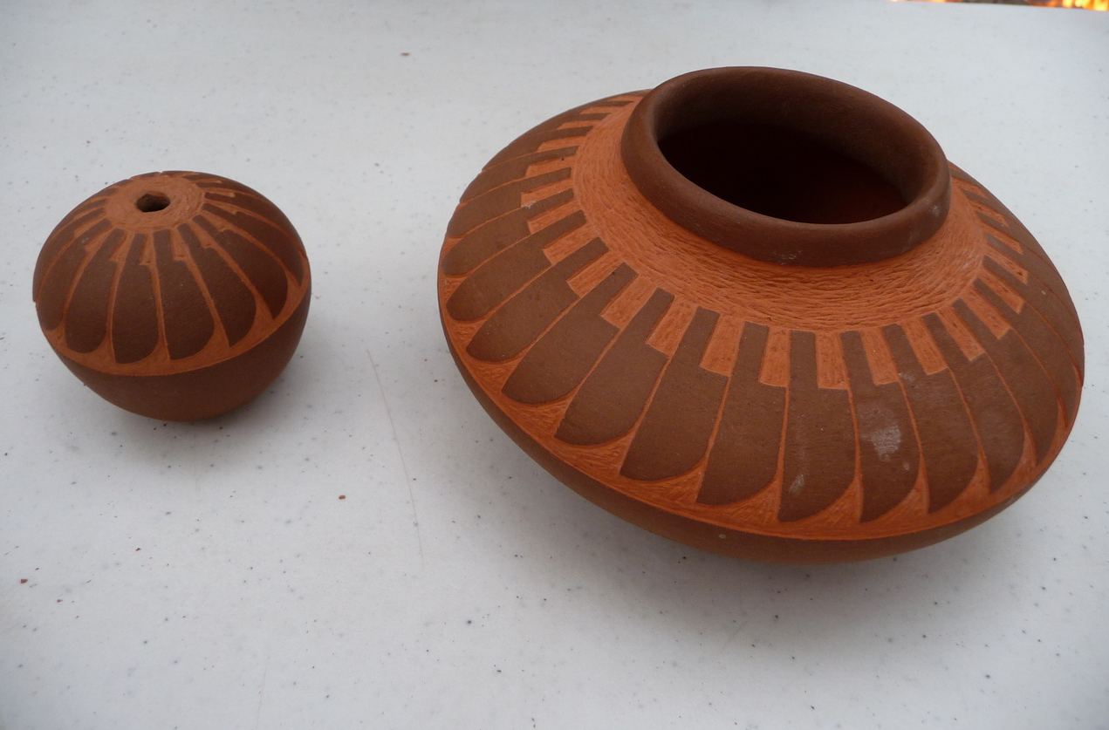

OVERVIEW:
- Lesson Summary: Students will understand how nature is present in their everyday lives by examining the world around them, and viewing the pottery of Native Americans. Students will create a clay pot utilizing natural elements and drawing inspiration from Native American pottery.
- Artists/Artworks/Artifacts: Native American Pottery
- Key Concepts:
  - Natural materials are all around us.
  - Natural materials connect us to nature.
  - Natural materials are versatile.
  - Natural materials are used throughout cultures to create useful items.
  - Natural materials are can be replaced and can be transformed into man-made items.
- Essential Questions:
  - What is considered a natural material?
  - Where can natural materials be found?
  - How do natural materials inspire people?
  - Why do we use natural materials to create useful things?
- Standards:
  - 9.1.3.B: Recognize, know, use and demonstrate a variety of appropriate arts elements and principles to produce, review and revise original works in arts.
    - Visual Arts: paint, draw, craft, sculpt, print, design for environment, communication, multi-media
  - 9.1.3.C: Recognize and use fundamental vocabulary within each of the arts forms.
  - 9.1.3.D: Use knowledge of various styles within each art form through a performance or exhibition of unique work.
  - 9.1.3.J: Know and use traditional and contemporary technologies for producing, performing, and exhibiting works in the arts or the works of others.
    - Know and use traditional technologies (e.g., charcoal, pigments, clay, needle/thread, quill pens, stencils, tools for wood carving, looms, stage equipment).
    - Know and use contemporary technologies (e.g., CDs/software, audio/sound equipment, polymers, clays, board-mixers, photographs, records).
- Interdisciplinary Connections:
  - Reading, Writing, Speaking, and Listening
    - 1.1.1.C: Use increasingly robust vocabulary in oral and written language. Students are learning many new vocabulary words from this project, such as texture, imprint, shape, etc.
  - Environment and Ecology
    - S4.B.3.1.2: Describe interactions between living and nonliving components (e.g. plants – water, soil, sunlight, carbon dioxide, temperature; animals – food, water, shelter, oxygen, temperature) of a local ecosystem. Students are examining and learning about how nature affects their lives.

OBJECTIVES:
The students will…
- Knowledge:
  - Students will learn about Native American pottery by looking at, reading, and discussing the handouts provided in both small group and class discussions. Formative assessment: teacher observation and notes during class discussion
  - Students will recognize how Native Americans used natural materials to create things by looking at, reading, and discussing the handouts provided, and applying the knowledge to making their own pot. Summative assessment: exit ticket and pinch pot decoration
  - Students will recognize and use vocabulary relating to Native Americans and pottery. Formative assessment: vocab worksheet—pot decoration
  - Students will know clay and paint rules by participating in class discussion and activities (card sorting and thumbs up/down/side). Pre-assessment: card sorting activity and thumbs up/down/side
  - Students will demonstrate their ability to recognize natural materials and their uses through in class identification activity. Formative assessment: teacher notes/observation of student responses
- Skills:
  - Students will identify and collect natural materials for use with their pots by taking a nature walk. Formative assessment: teacher observation/notes on class discussion, game Real/not real, and collection and use of natural elements
  - Students will demonstrate their ability to create a “pinch pot” out of clay using hands on practice. Summative assessment: pinch pot with natural materials/impressions
  - Students will decorate their “pinch pots” with impressions made from at least three different natural materials. Summative assessment: One on one teacher/student critique (checklist) and student reflection
  - Students will paint their pinch pot using natural colors, inspired by the decorations on Native American pottery. Summative assessment: One on one teacher/student critique (checklist) and student reflection
- Dispositions:
  - Students will generate ideas for how they will use their pot and fill out an exit card stating this, then share some of these ideas with the class. Formative assessment: teacher observation/notes on class discussion. Summative assessment: exit card
  - Students will understand how natural materials are used in the world around them through a nature walk and class discussion. Formative assessment: Teacher notes/observations during class discussion

ASSESSMENT:
- Pre-assessment:
  - Students will display their knowledge of clay and paint rules through the Thumbs up/side/down and “yes/never” card sorting activities and class discussion.
- Formative assessment:
  - Students will engage in various class discussions and exploration about what natural materials are, where they are found/how they are used in our world.
  - Students will go on a nature walk to collect natural materials.
- Summative assessment:
  - Students’ completed pinch pots will be assessed by a checklist during a one on one student/teacher mini critique.
  - Students will fill out the smile self assessment for their pinch pot.
  - The exit tickets and vocabulary worksheet will also be noted.

INSTRUCTIONAL PROCEDURES:
- Day One
  - Motivation and Engagement:
    - Teacher will lead students on a nature walk around the school grounds. Students will be in groups by tables. Each group is responsible for collecting several natural materials to bring back to the classroom (sticks, stones, leaves, flowers, etc.). Teacher will ask students why they selected the materials they did (natural) and how they knew the object were “natural.” Teacher will point to or hold up different objects and ask students if they are “real or not real.” (real=natural, not real=not natural.)
      - What is considered a natural material?
      - Where can natural materials be found?
  - Development:
    - Students will return to their tables with their natural materials from the nature walk and will have small group discussions of what the natural materials could be made into. The small groups will then share their ideas for their object(s) with the whole class.
      - Sticks
      - Rocks
      - Leaves
      - Pine cones
      - Flowers
      - Pine needles
    - Teacher will show the students images of different objects made from natural materials for the student to identify and state what natural material was used to make the object.
      - Images:
        - Paint/perfume—flowers
        - Paper/houses—wood/trees
        - Sidewalks/garden wall—stones
        - Mulch/compost—leaves
    - Students will be shown and given information on Native Peoples. They will learn how Native People used natural materials to survive—i.e.-making clothing, shelter, and tools (like pots!). Remains of Native People that are most commonly found are pieces of pottery.
      - Coil Pot
        - Tradition
        - Score and slip
      - Natural Materials
        - Clay- comes from the earth, like dirt
      - How do natural materials inspire people?
    - Discuss traditional decorations with the students
      - “What do you see?”
      - Discuss terms and point out examples:
        - Shape
        - Pattern
        - Texture
    - Teacher will hand out the Pot decorating worksheet and drawing materials for students to fill out. Students will draw or fill in the appropriate examples of the vocabulary.
      - Texture- glue crumpled tissue paper
      - Shape- draw examples of shapes
      - Pattern- draw example of repeating pattern
      - Imprint- use stamps/stamp pad to make “imprint”
  - Culmination:
    - Discuss clay rules with the students. Present the students with options of what to do with the clay (i.e. eat it, throw it, step on it, mold it, etc.) and have them give a thumbs up or thumbs down to indicate good idea versus bad idea.

- Day Two
  - Motivation:
    - Students will be given different examples of the vocab words (i.e. sandpaper, a square/circle/triangle, and , along with cards with the word written on them. In small groups, the students will match the card to the example.
  - Development:
    - Teacher will ask students to share different clay rules with the class. The class will then either agree or disagree with the student’s statements.
    - Teacher will demonstrate how to make a pinch pot. Teacher will then demonstrate how to roll out a coil (i.e. no thinner than your thumb, try to keep it even, etc.). Teacher will show students how to score and slip, and explain why this is important to attaching clay together.
    - Students will have the option to make pinch pots out of clay, or to add coils to their pinch pots and will create textures with natural materials provided by the teacher. Students may also embed natural materials into the pot itself. Students may add handles, lids, and feet for the pinch pots if they feel inclined.
      - Sticks
      - Rocks
      - Leaves
      - Pine cones
      - Flowers
      - Pine needles
    - Make sure students carve name/initials on bottom of pot and/or write name on paper/paper plate underneath pot.
  - Culmination:
    - Students will clean up supplies and put pots out to dry. Students will then return to their seats and fill out an “Exit Ticket” requiring them to state how they plan to use their pot, and how Native Americans traditionally used their own pottery. They will hand the “tickets” in in order to leave.

- Day Three
  - Motivation:
    - Teacher will discuss painting procedures with class, giving each table several cards listing procedures. Students will sort the cards into a “yes” pile and a “never” pile. Teacher will then ask students to share one of the cards, and the class will state which pile it belongs in.
  - Development:
    - Students will have the opportunity to paint their pots with natural colors of paint, and naturally made paint (if possible).
    - Students will have free drawing time if they finish early
  - Culmination:
    - Teacher will come around as students are working on their self-assessment sheets to have a one on one mini critique and fill out the project checklist.
    - Students will fill out the self-assessment and reflection sheets and share them with each other in small groups at their tables.

PREPARATION:
- Teacher Preparation:
  - Research and gather images of Native People
  - Create handouts with research and images (for student reference)
  - Create step-by-step guide to making pinch pots, coil pots, and scoring and slipping (poster).
  - Gather natural materials for hook and impressions (prep for nature walk)
  - Create Exit Tickets for students to fill out before leaving
  - Create rating scale for one on one teacher student critique
  - Create vocabulary worksheet
- Research:
  - http://www.native-languages.org/pottery.htm
  - http://www.indians.org/articles/american-indian-pottery.html
  - http://www.clayhound.us/gallery/265.htm
  - http://www.nysm.nysed.gov/IroquoisVillage/slidetwoa.html
  - http://www.denverartmuseum.org/collections/american-indian-art
  - http://www.indianvillage.com/indianarts/potteryexamples.htm
- Student Supplies:
  - Natural materials (stones, sticks, leaves, pine needles & cones, mulch, etc.)
  - Handouts
    - Native American information and visuals
    - Vocab worksheet
    - Exit ticket
  - Clay (either air-dry or real clay/glaze)
- Vocabulary:
  - Native People- a member of the people living in North or South America before the European explorers and settlers arrived.
  - Natural materials- materials found in nature
  - Pinch Pots- bowl or vessel created with a pinching technique
  - Coil Pot- bowl or vessel made using coils of clay
  - Scoring and slipping- technique to put two pieces of clay together (like coils or handles). Consists of making the surfaces rough and applying water or slip so the pieces will stick together.
  - Texture- how a surface looks and feels.
  - Shape- outline of a specific object.
  - Pattern- a decorative design, sometimes repeating
  - Imprint- a mark made by applied pressure
- Adaptations:
  - Older grades:
    - Make an entire coil pot
    - Make and use naturally made paints
    - Fire and glaze pots so they can be used for food.
  - For students with a hearing disability, visuals and written instructions will be provided. (i.e. poster showing steps of making a pinch pot and the concept of score/slip)
  - For students with a physical disability, or some kind of problem with clay, there will be the option to create a 2D collage from the natural materials, depicting one of the ways a vessel like a pot is useful to humans and/or was used by Native Americans.
  - For students with a reading or visual impairment, oral explanations and critique will be provided, and student self assessment will be given orally by teacher, with student(s) responding with

Exemplars:

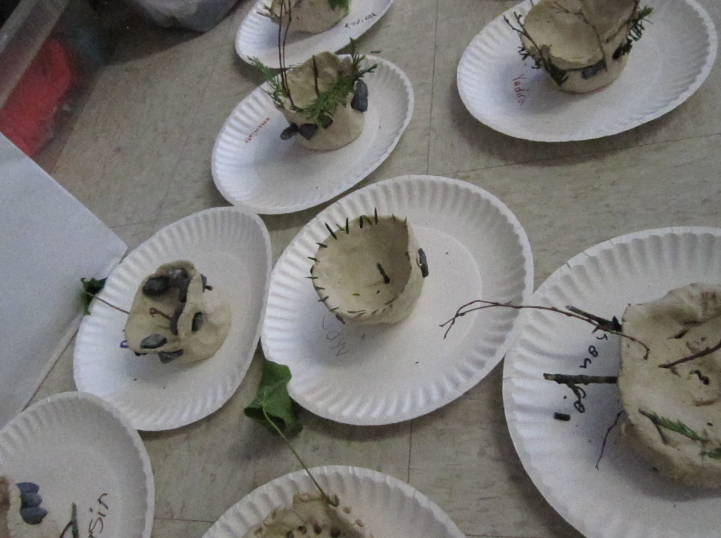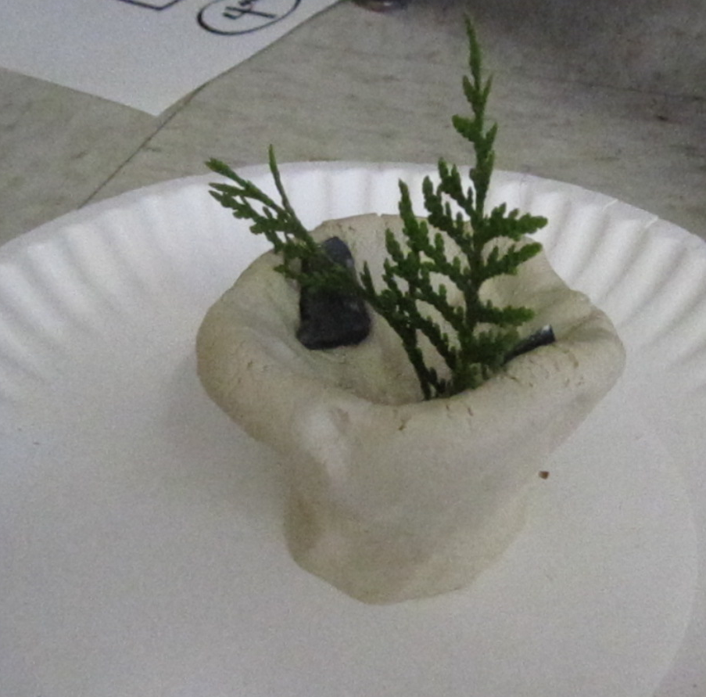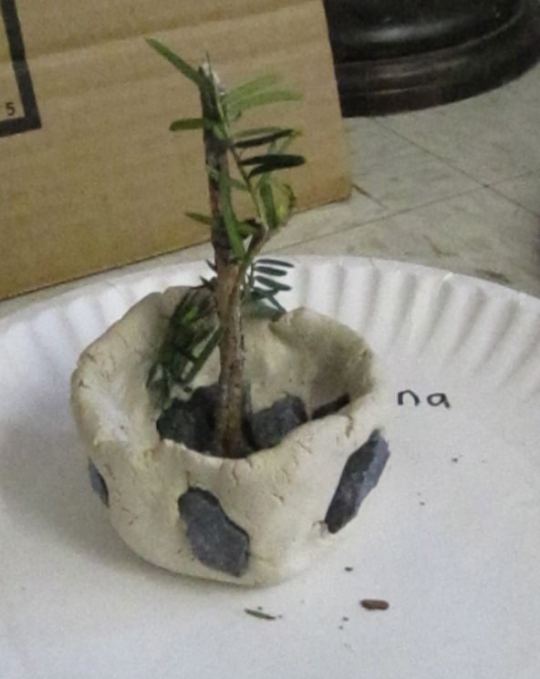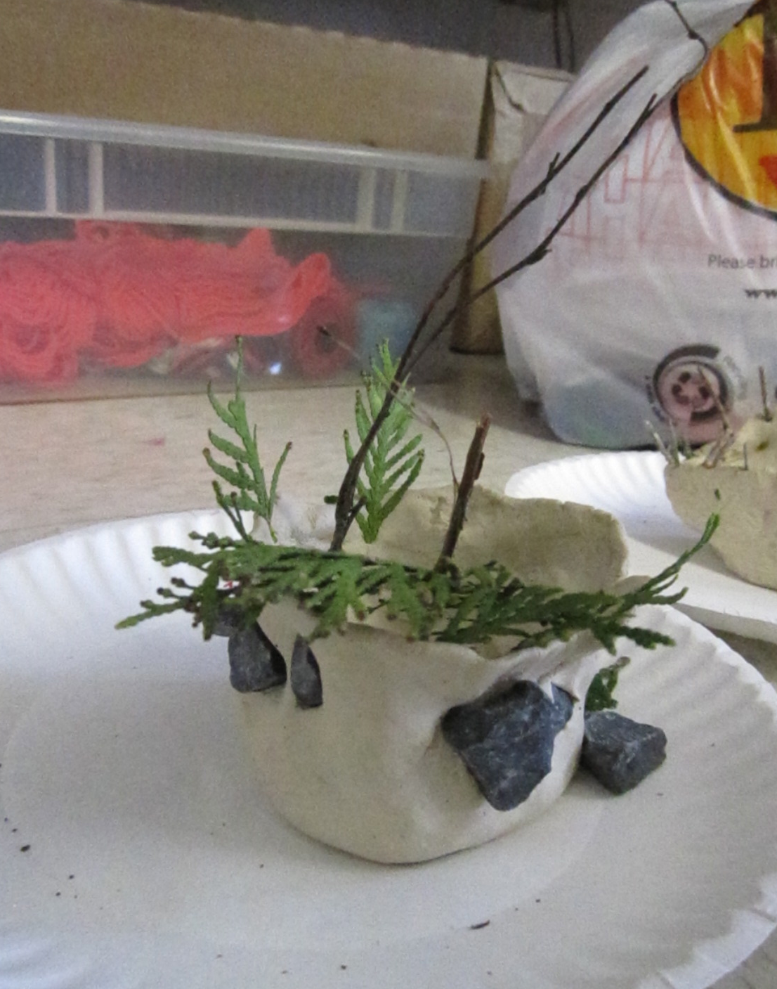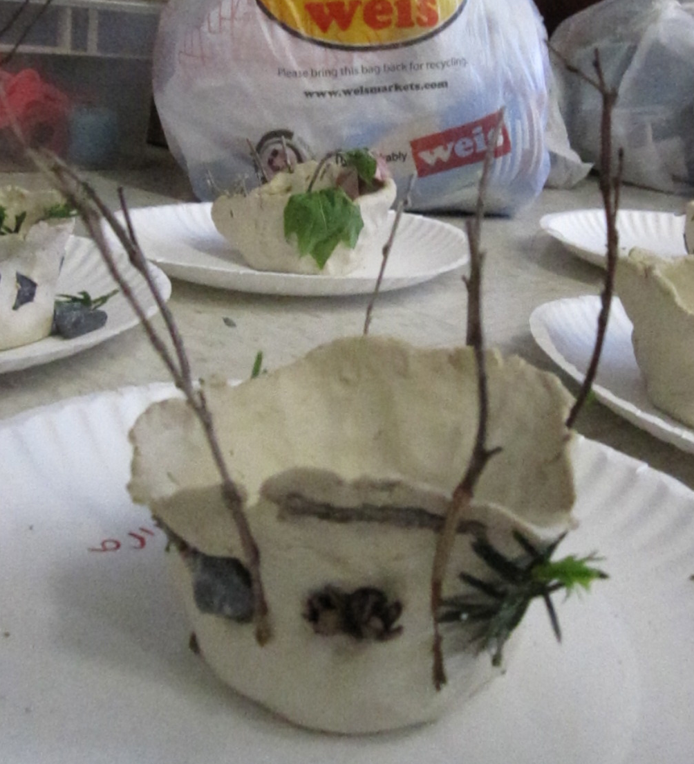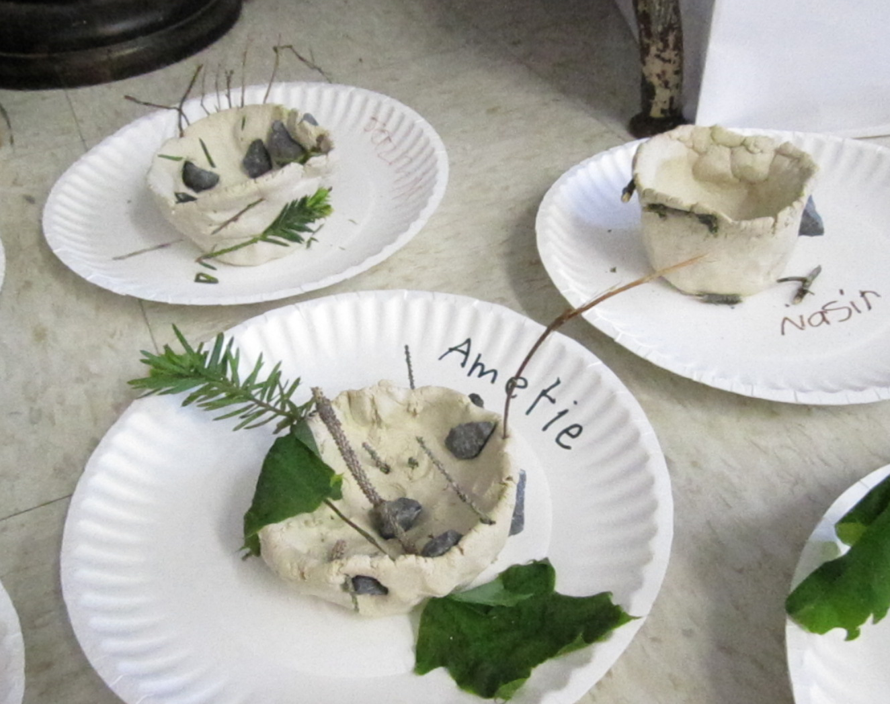

Student Self Assessment

Tell me how you feel about your artwork by drawing a…

Sad face
Straight face
Smile face

I created a sturdy pinch pot that stood up on it’s own, and can hold something.

I used at least three different natural materials in my pot.

I showed texture, shape, pattern, and imprint in my pot.

I followed directions, such as the clay and paint rules.

Exit Ticket:

What will you use your pot for? (circle or fill in blank)
- To hold pencils
- To hold coins
- Other: _____________________________

What did Native Americans use their pottery for? (circle correct answers)
- To hold food
- To hold clothing
- To hold water
- For storage
- To hold dirt/natural materials

Exit Ticket:

What will you use your pot for? (circle or fill in blank)
- To hold pencils
- To hold coins
- Other: _____________________________

What did Native Americans use their pottery for? (circle correct answers)
- To hold food
- To hold clothing
- To hold water
- For storage
- To hold dirt/natural materials

Decorate your own Native American Pottery
Draw examples of the vocab words (listed below)

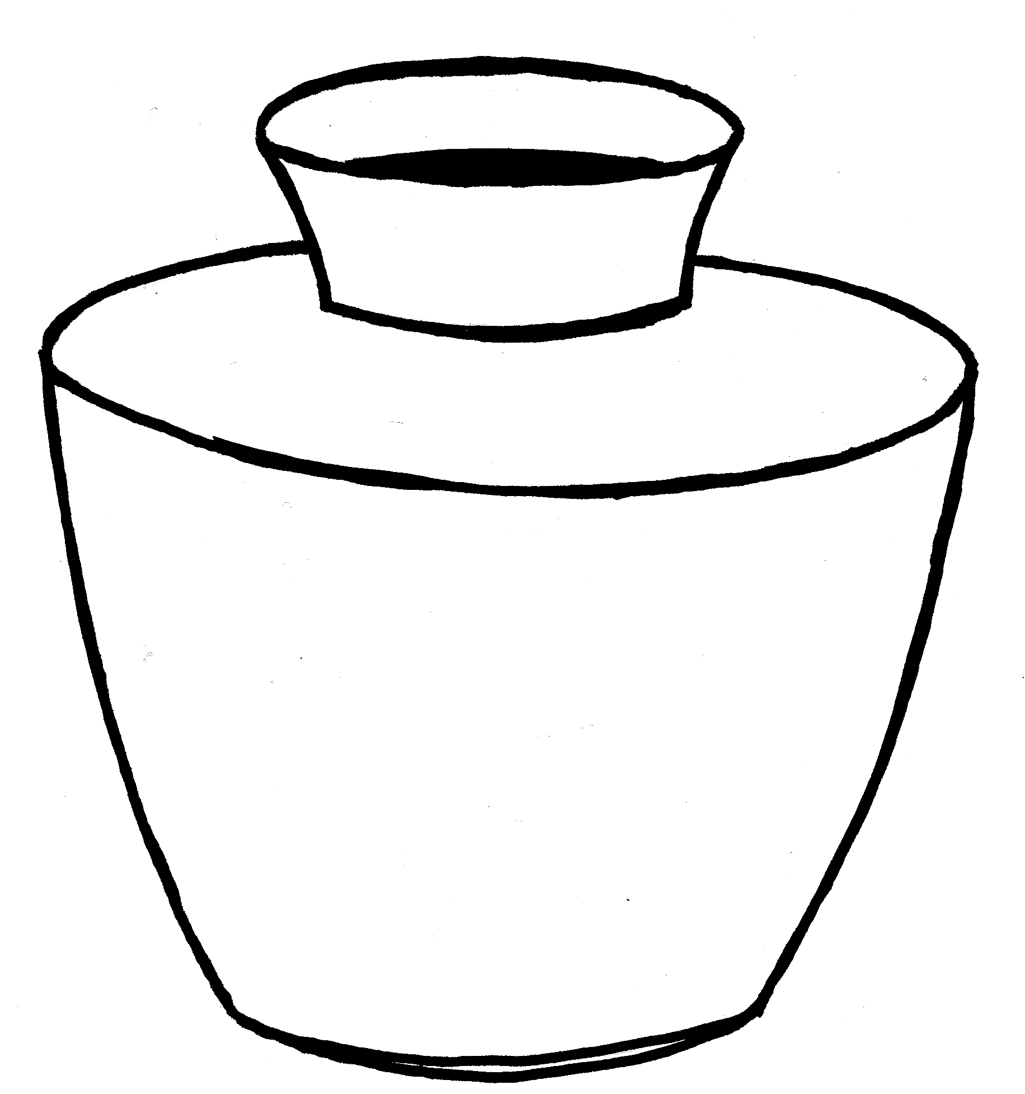

Match the word to the definition:
Pattern
- How a surface looks and feels
- A decorative design. Can repeat.
- The outline of a specific object
- A mark made by pressing on an object

Shape Imprint
Texture

Pinch Pot Checklist Assessment:

_____ Student created a Pinch pot/coil pot out of clay, and painted it using natural-based paint.
_____ Student used at least three different natural materials.
_____ Student applied knowledge of the terms texture, shape pattern, and imprint.
_____ Student created a pot that can hold an object (be useful).

