**Planting a Rainbow**

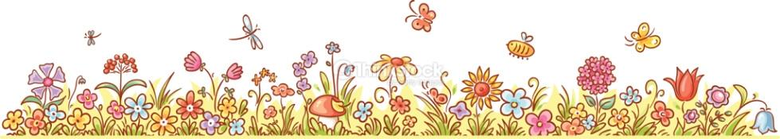

**_____________________________________________________________________________________________**

**Enduring Idea (Big Idea)**: Color can be found all around us

**Lesson Title:** Planting a Rainbow

**Grade/Class:** 1st grade

**Time Allotment:** Three 45 minute periods, students have art once an eight day cycle for the full year

**_____________________________________________________________________________________________**

**OVERVIEW**:

1. **Lesson summary:** Students will be introduced to the idea of Primary and Secondary colors using the book Planting a Rainbow. Students will create 2 flowers or plants, one based on primary colors, and one a secondary color that they mixed themselves.
2. **Artworks, artists and/or artifacts:**
   1. Book: *Planting a Rainbow*, Lois Ehlert
   2. 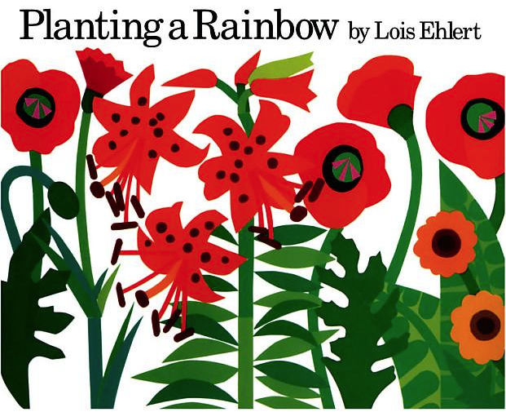
3. **Key concept(s):**
   1. Primary colors are the FIRST colors; they cannot be mixed
   2. Secondary colors are created by mixing primary colors
   3. Color is present in our everyday lives; in nature, media, in different objects
4. **Essential Questions:**
   1. In what ways can you make the primary and secondary colors?
   2. Why are primary colors important?
   3. Where do we see color in the world around us?
5. **Standards**
   1. PA Standards for Arts & Humanities:
      1. 1.1.D: Use art materials and tools in a safe and responsible manner
      2. 1.1.A: Know the differences between materials, techniques, and processes
      3. 1.6.B: Identify connections between the visual arts and other disciplines in the curriculum
   2. PA Standards for other disciplines:
6. **Interdisciplinary connections:**
   1. Reading and Language arts connections: This lesson features a literary element; *Planting a Rainbow*, by Lois Ehlert.
   2. Science Connections: Through the book, students will also learn about various types of plants, connecting the lesson to science and biology.
   3. Math Connections: This lesson utilizes “color equations” that include math notation (equal and plus signs).

**_____________________________________________________________________________________________**

**OBJECTIVES**:

**The student will...**

1. **Knowledge?**
   1. Students will identify and define Primary and Secondary colors
   2. Students will match primary colors with the secondary color that they create
2. **Skills?**
   1. Students will create a flower using the primary colors.
   2. Students will demonstrate their understanding of secondary colors by mixing primaries together to create a secondary color with which they will paint a second flower.
3. **Dispositions?**
   1. Students will demonstrate respect for their classrooms and teachers by properly handling the tools and supplies they use; keeping things clean, keeping paint contained

**_____________________________________________________________________________________________**

**ASSESSMENT**: How will you be assured that your students know each objective?

Pre-assessment:

* Question students about previous knowledge of colors using the color wheel

Formative Assessment:

* Students will use thumbs up/thumbs down to display their knowledge of the primary colors.
* Students will recite the definition of color (with hand motions), without teacher assistance.
* Students will fill out a color equation worksheet with the secondary colors, and which primary colors are used to mix them
* Students will mix and use their own secondary colors of paint

Summative Assessment:

* Students will keep their classrooms clean, and use paint and painting supplies correctly and appropriately.
* Students will have two painted flowers; one using the primary colors, the other using the secondary colors.

**_____________________________________________________________________________________________**

**INSTRUCTIONAL PROCEDURES:**

**Day 1:**

1. **Motivation/Engagement:** To begin the class, I will read the book *Planting a Rainbow,* by Lois Ehlert (or use the Doc Cam if that will work better in a particular classroom). This will be my introduction to colors. While reading, I will engage students by discussing the plants and asking students to participate in identifying the colors in the book. (10 minutes)

2. **Development:** After we read the book, we will go over the definition of Color, and say it and do the hand motions together three times. I will show them a color wheel, and we will look at color relationships together. I will introduce the primary colors (red/yellow/blue), saying that PRIMARY colors are the FIRST colors, like first grade. I will ask students, if red yellow and blue are the primary colors, then what might the secondary colors be? Allow students several tries to answer. (5 minutes)

After going over definitions with the students, I will introduce the project; students will create two flowers. One will be made of the primary colors. The second flower, they will choose one of the secondary colors and mix it for the petals. (“just like the author and her mother were planting a rainbow in the book we read, we’ll have a chance to create our own rainbow to plant” etc) (2 minutes) necessary??

We will begin by drawing out our flowers. I will do a step by step demo with the students to draw the first flower, and then they will draw the second one on their own. I will start with the center of the flower, making a circle at the center of the page. Then, we will add petals (up to 7), by drawing circles/half circles that are attached to the center circle. After adding petals, we will draw a stem coming out from the bottom, with a leaf on it.

After the students draw two flowers, I will do an introduction to color mixing. I will hand out the color equasion sheets and markers for students. Under the doc cam, I will demonstrate mixing colors, engaging students in the process by asking them which colors to mix, and quizzing them on what color is made. They will follow along on their worksheets, filling in the equations with the correct colors (red+blue=purple, blue+yellow=green, yellow+red=orange).

3. **Culmination/Close:** I will collect everyone’s color equations so that they have them for reference next class. After we are all cleaned up, I will go over the definition of Color with the students again, to make sure that they remember it. We will thumbs up/thumbs down which colors are primary colors.

**Day 2:**

1. **Motivation/Engagement:** To start off the day, we will review color mixing using Mrs. Sousa’s color paddles. I will say a secondary color, and ask students to use the paddles to show me which primary colors I need to use to make that color. (5 minutes)

2. **Development:** After reviewing, we will dive right in with painting! This is our only painting/work day. We will start by painting our primary colored flowers (all three of the primary colors are to be used; one for the petals, one for the center, and one for the stem/leaves). After the students finish their primary colored flower, we will move on to mixing colors. Students will each choose one color to mix, and will share paint with partners to use all three secondary colors. Students will also have their Color equation worksheets to use for reference. (15 minutes primary colors, 20 minutes secondary colors, 35 minutes total) To mix colors, I will put a small amount of each primary color in a cup for the students to then mix.

We will set wet flowers out to dry in the teacher’s classrooms??

3. **Culmination/Close:** We will finish the day by making sure we are all cleaned up, and then once again reviewing our definitions.

**Day 3:**

1. **Motivation/Engagement:** We will begin by going over the definition of color together, reciting it and doing the hand motions. I will ask students to tell me which colors mix each secondary color.

2. **Development**: After reviewing color mixing, students will get their flowers back. We will then cut out our flowers. Students will choose one to paste onto a colored construction paper background, which they will then decorate with construction paper crayons. They will bring the other one (they choose which), up to be added to the class’s “garden.” Each student will have a flower, either their primary or secondary flower, in the class garden. These will stay with the classroom teacher to be displayed.

3. **Culmination/Close**: The end of class will be a clean up session, and we will look at everyone’s flowers, and view the rainbow that we all “planted.” I will ask students about where they planted their personal flower before discussing the class garden. There will be all different colors in our garden, just like in the book, and in real life. We will go over our definition of color one more time, just to make sure the students all have it.

**_____________________________________________________________________________________________**

**PREPARATION**:

1. **Teacher research and preparation:** 
   1. Color definition: Color EXCITES our world
   2. Primary colors: Primary colors are the FIRST colors; They can’t be mixed. (red yellow and blue)
   3. Secondary color: Secondary colors are made by mixing together two primary colors. They are found on the color wheel in between the colors that create them. (orange, green, purple)
2. **Instructional Resources:**
   1. *Planting a Rainbow,* Lois Ehlert
3. **Student Supplies:**
   1. Tempra paint
   2. color paddles
   3. paint brushes
   4. paint cups
   5. baby wipes (art on a cart)
   6. scissors
   7. 9x12” white paper and construction paper
   8. construction paper crayons
   9. glue
   10. markers
4. **Accommodations:**
   1. ESL: By using the color paddles and the color equations, students will have visual means of understanding color mixing.
   2. Learning Disabilities/motor skills: Students will complete the project using markers/crayons instead of paint if that is easier for them to use
   3. Visual impairments: Students with visual impairments will be able to participate in this project by using textured paint (different textures for different colors) so that they can differentiate between them. Potentially, students could also finger paint instead of using brushes.
5. **Images of Student work:**





COLOR EQUATIONS:

Fill in the boxes to show which two primary colors combine to create which secondary color

 **+**  **=** 

 **+**  **=** 

 **+**  **=** 