**“My Big Catch”**

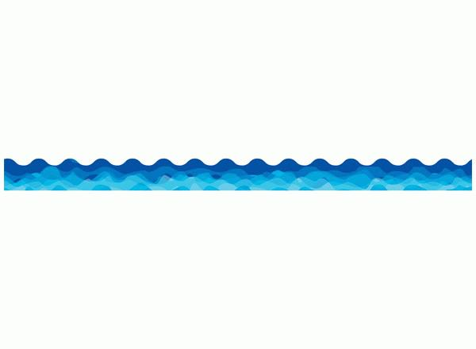

**___________________________________________________________________________________________________**

**Enduring Idea (Big Idea)**: Art is used to preserve memory (Memory can be preserved in many ways)

**Lesson Title**: “My Big Catch”

**Grade/Class**: 3rd grade

**Time Allotment**: 3 45 minute periods, art class 1 time per 8 day cycle

**___________________________________________________________________________________________________**

**OVERVIEW**:

1. **Lesson summary**: In this lesson, students will be traveling to Asia, specifically Japan, through the exploration of the Japanese art of Gyotaku, or fish printing. Students will create a watercolor background, print their fish, and write a haiku for the final project.
2. **Artworks, artists and/or artifacts**: Gyotaku (fish printing)

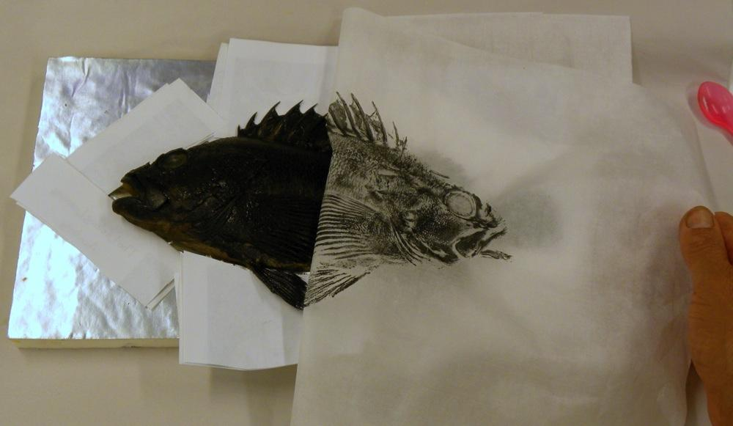

1. **Key concept(s)**:
   1. Art can be a visual record of memories
   2. Art does not require words to communicate
   3. A memory is a story from our past
2. **Essential Questions**:
   1. How does art preserve memory?
   2. Why use art to record a memory?
   3. What is a memory?
3. **Standards**:
   1. PA Standards for Arts & Humanities:
      1. 9.1.3.C. Recognize and use fundamental vocabulary within each of the arts forms.
      2. 9.2.3.G. Relate works in the arts to geographic regions: •Asia
      3. 9.2.3.F. Know and apply appropriate vocabulary used between social studies and the arts and humanities.
   2. PA Standards for other disciplines:
      1. 7.1.3.B Identify and locate places and regions as defined by physical and human features.
      2. CC.1.4.3.M Write narratives to develop real or imagined experiences or events.
4. **Interdisciplinary connections:**
   1. Language Arts: Students will use writing skills to create a haiku for this project.
   2. Geography: Students will learn where Japan is located
   3. Social Studies: Students will learn about Japanese culture

**___________________________________________________________________________________________________**

**OBJECTIVES**:

**The student will...**

1. Knowledge?
   1. Students will define Gyotaku and its history during class discussion/review each day
2. Skills?
   1. Students will create a watercolor background for their gyotaku print
   2. Students will create their own gyotaku prints, one practice and one final print, demonstrating their knowledge of the process
   3. Students will synthesize a memory by writing a haiku about their “catch”
   4. Students will matte their prints and haiku
3. Dispositions?
   1. Students will demonstrate respect for their classrooms and teachers by properly handling the tools and supplies they use; keeping things clean, keeping ink contained
   2. Students will illustrate their understanding of the purpose of Gyotaku by writing a haiku about “their big catch”

**___________________________________________________________________________________________________**

**ASSESSMENT**:

Pre-assessment:

* Airplane ride to Japan (students use clues to discover their destination??)
* Questioning students about Japan during power point

Formative assessment:

* Making connections between Japanese and America during power point
* Practice Gyotaku print on news print
* List of fishing words for use in Haiku

Summative assessment:

* Completed Gyotaku print, with watercolor background
* Completed Haiku (5/7/5 syllables) about how they caught their fish
* Checklist (fish ticket)

**___________________________________________________________________________________________________**

**INSTRUCTIONAL PROCEDURES:**

**Day 1**

**Motivation/Engagement**: I will begin the day by telling the class that we are moving on to our next destination. I will ask the class to close their eyes, and imagine getting on to an airplane. I will ask if anyone has ever been on a plane before (show of hands), then discuss what it is like (briefly). I will say talk about the cramped seats, and looking out the window, we see clouds all around us. After a while, we see water beneath us. We circle down to an island and touch down. (play Japanese music and tell the class the smell of cherry blossoms is wafting through the air). Ask the class where they think we might be. (5 minutes)

**Development**: After hopefully getting the class to guess Japan, I will move into my power point introduction to Japan. We will talk about how Japan is an island in the Pacific Ocean, surrounded by water. So fishing is a large part of their culture. From there, I will introduce Gyotaku, define it, and discuss its history. (have images of fishermans’ biggest catch type photos) (15 minutes)

From there, I will introduce the project. I will tell students that they will be able to create their own Gyotaku piece. We may not be going fishing ourselves, but we will pretend, and we will be able to show our “biggest catches.” We will use rubber fish instead of real ones, but we will print them the same way. I will show students my example. We will begin the project by creating a watercolor background for our fish. I will demonstrate how to use the watercolors, discussing how much water to use, how to blend colors, etc. I will also discuss what a “wash” is in watercolor, and how students should use color, instead of trying to create an image (“remember, you will be printing your fish over top of the watercolor, so you won’t be able to see it if you paint a picture”) (5 minutes)

Students will then be able to create their watercolors at their tables. THEY WILL WRITE THEIR NAMES ON THE BACK OF THEIR PAPERS IN PENCIL FIRST. Students will use either the warm or cool color families to complete their water color. (15 minutes)

**Culmination/Close**: 5 minutes from the end of the period, students will begin to clean up. I will collect paintbrushes and water cups (pouring out water into larger container??). Paper towels and baby wipes will be distributed as needed (students should clean up their desks). After everyone is cleaned up, I will wrap up with a review. I will ask the class what Gyotaku is, and for some facts about it. I will also ask the class what continent and country we are now in, to make sure that they remember. I will tell the students to be ready for the next class, when we will actually be printing the fish! (5 minutes)

**Day 2**

**Motivation/Engagement**: To begin calss, I will show students a “biggest catch” photo, and that will be students only prompt/hint as to what we are doing. I will ask students to recall what we are working on; see if they remember the word “Gyotaku” and what it means. Why would people print fish? I will also ask to see if they know WHERE we are, both continent and country. (5 minutes)

**Development**: From there, we will dive right in (pun intended) to our fish printing. I will demonstrate how to use the block printing ink and brayer. I will discuss how much ink students should use (SMALL AMOUNT), as well as how to evenly coat the brayer. Using the brayer, they will roll ink onto the fish form, making sure to get into all of the nooks and crannies, with an even coat of ink on the fish. Then I will demonstrate how students should lay their paper on top of the fish. DO NOT MOVE THE PAPER!! Press the paper firmly onto the fish form, making sure to get along the sides, and into the nooks and crannies as best you can. Once you have firmly pressed down the paper EVERYWHERE, carefully peel the paper off of the fish form. **area will be covered with newspaper, and printing ink will be put on a paper plate as a palette** Students will create two prints; a practice one on newsprint, and then their final print. (5 minutes)

Students will then be able to begin their own fish prints. I will hand back their watercolor background, and set up four printing stations. Students will be able to choose which color they use to print their fish. (I will encourage making sure it CONTRASTS with their background, so they can see the fish). (20-25 minutes to print)

After all students have printed their fish (or potentially two fish), we will clean up. Paper towels and baby wipes will be distributed as needed. Fish prints should be left on students’ desks to dry, all other materials put away. (5 minutes)

**Culmination/Close**: To wrap up, I will introduce the idea of Haiku poems briefly, and tell students that is what we will be doing next class. We will brainstorm words that have to do with fishing, to use in our Haikus next class. I will write them on a large sheet of paper, and save each class’s list with their portfolios.

**Day 3**

**Motivation/Engagement**: We will begin by doing a mini critique; I will have all students get out their Gyotaku prints, and hold them up in the air to show them to me, then show them to each other. I will tell students that today we will finish their gyotaku projects, by telling the story of how we “caught” them.

**Development**: From there, we will review Gyotaku and Japan, then Haiku. I will ask what students remember (# of syllables, what a syllable is, usual topics of haiku, etc.). I will go into greater detail about how a haiku is written (syllables, etc.), and I will post my example Haiku on the board so students have it for reference. I will post our list of fish/fishing related words on the board, and take a moment for students to add to it. I will say that these are words they could use in their Haiku.

After our review, we will get right into writing our haiku. Students will write it in pencil on scrap paper first, then have ti checked by me. Once I have checked it, I will give students a final piece of paper (small size to attach to the watercolor print). They will write out their haiku in pencil, then trace over it in thin-tip sharpie. After they have done that, we will matte it and attach it to their Gyotaku print.

**Culmination/Close**: To wrap up, I will once again ask students to tell me what it is we’ve been doing. (Gyotaku, fish rubbings, rice paper, etc) As the final part of this lesson, since we printed our fish, and it is traditional to cook and eat a fish after you print it, we will eat goldfish crackers to hold up that tradition of gyotaku.

**___________________________________________________________________________________________________**

**PREPARATION**:

**Vocabulary:**

* 1. Gyotaku: fish rubbing/ fish print
  2. Brayer: print making tool, used for rolling ink
  3. Watercolor wash: technique of creating a gradient using watercolors

**Instructional Resources:**

* 1. <http://web-japan.org/kidsweb/explore/>

**Student Supplies:**

* 1. White drawing paper (9x12”)
  2. Watercolors
  3. Paintbrushes
  4. Block printing ink
  5. Brayers
  6. Paper plates
  7. Fish forms for printing
  8. Pencils
  9. Writing paper (pre-cut, 6 lines)
  10. Pre-cut matting paper for Print and Haiku (10x13” and 9x3”)

**What changes, if any, did you make to the lesson? What would I change or modify the lesson for next time?**

* I think I would like to bring in a science element to this in the future. If I could make sure to only use local fish, and we as a class could discuss the fish species and conservation in greater detail. We would also add a label, with the fish species (or scientific name?) on the top.
* In a more summer camp setting, I would love to actually be able to print real fish and take the class to the lake/stream to discuss fishing and ecology
* With more time, bringing in a calligraphy/cursive element to it to write the haiku or to write the fish species

How will you adapt this lesson to meet the needs of students with challenges or students who already have a basic working knowledge of the topic being taught? (At least three possible modification)

* 1. If students finish early, they may draw an image of their haiku, illustrating the story of how they caught their fish.

**Student work:**

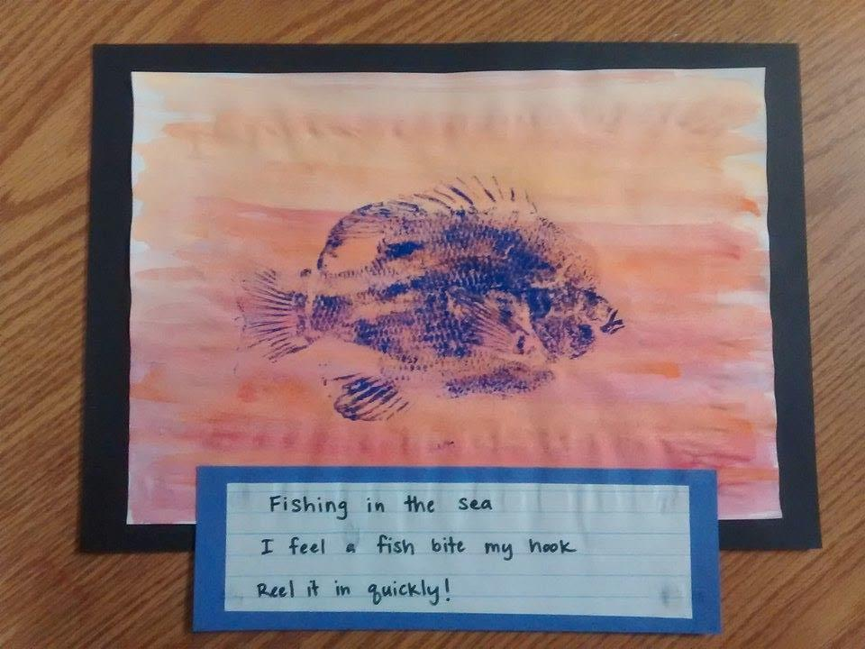

**FISH TICKET**

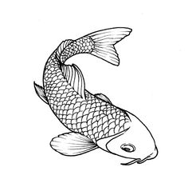

Did you….

* Paint your watercolor wash
* Print your fish
  + Practice Print on newsprint
  + Final Print on water colored paper
* Glue your Gyotaku print to a black Background
* Write a haiku
  + How you caught your fish
  + 5/7/5 Syllables
* Glue your Haiku to your Gyotaku print
* Put your name on the back

Congratulations! You have completed all of the steps. Redeem your checklist to receive your goldfish.